

**KOLEJ PROFESIONAL MARA BERANANG**

**DIPLOMA IN COMPUTER SCIENCE**

|  |  |  |
| --- | --- | --- |
| **COURSE NAME** | **:** | **WEBSITE APPLICATION DEVELOPMENT** |
| **COURSE CODE** | **:** | **CSC2173** |
| **ACADEMIC SESSION** | **:** | **SESSION 2/2022** |
| **TYPE OF ASSESSMENT** | **:** | **PRACTICAL TEST 1** |
| **DURATION** | **:** | **2 HOURS** |

**CLO 1: BUILD DYNAMIC WEBPAGE INVOLVING WEB DEVELOPMENT METHOD THAT ACCEPTABLE WITH SCENARIO GIVEN.**

**INSTRUCTION TO CANDIDATES:**

1. Time allowed is **2 HOURS.**
2. Execute all tasks.
3. Submit Django project folder (compressed/zip) and a document containing the screenshot in MS Teams.

|  |  |
| --- | --- |
| **Section / Question No.** | **Marks** |
| **Part A** | **/5.5** |
| **Part B** | **/12.5** |
| **Part C** | **/22.0** |
|  |  |
|  |  |
| **Total** | **/40** |

|  |  |
| --- | --- |
| **Personal Details** | |
| **Name** |  |
| **I/D Number** | **BCS 2107-** |
| **Class** | **DCS 4 [A] [B] [C] [D] [E]** |
| **Lecturer** | **PUAN NORAZIMAH [ ]**  **PUAN NURHANNANIE [ ]** |

### Overview

Tables shown below are part of Edgy Grocer company database.

Supplier

|  |  |  |
| --- | --- | --- |
| suppid (PK) | suppname | contact |
| S001 | Atap Biru Enterprise | 0126666777 |
| S002 | VE Fresh Mart | 0175656567 |
| S003 | Farego Halal Mart | 0198889999 |

Product

|  |  |
| --- | --- |
| proid(PK) | prodescription |
| P1 | Egg Grade A |
| P2 | Bestari Chicken Flour |
| P3 | Spritzer Mineral 9.5L |

Supplier_product

|  |  |  |
| --- | --- | --- |
| suppid (FK) | proid (FK) | price |
| S001 | P1 | 8.50 |
| S002 | P1 | 8.80 |
| S002 | P3 | 7.50 |

### Software requirement: Visual Studio Code

**Part A: Create a Django project (Task 1-3)**

* + 1. Create a django project name ‘yourstudentid’ for example: BCS2107001.
    2. 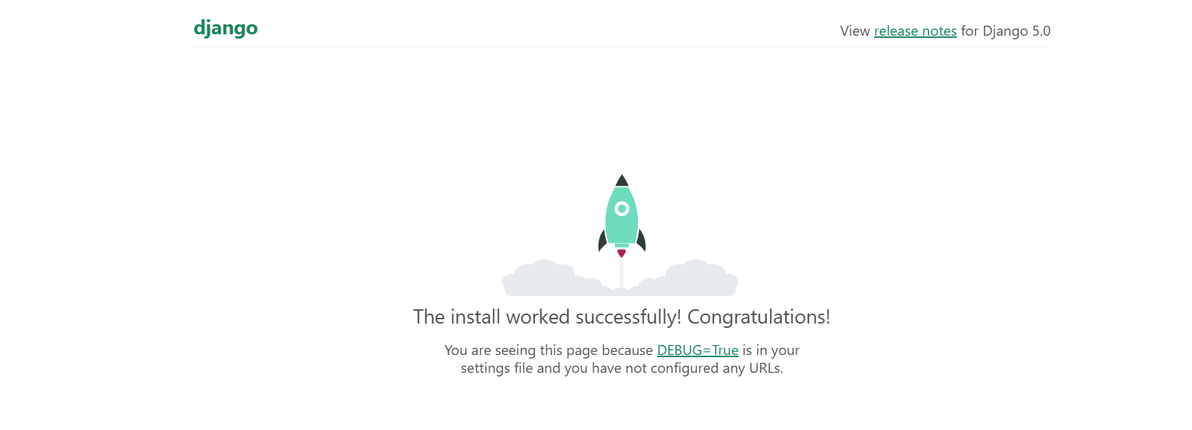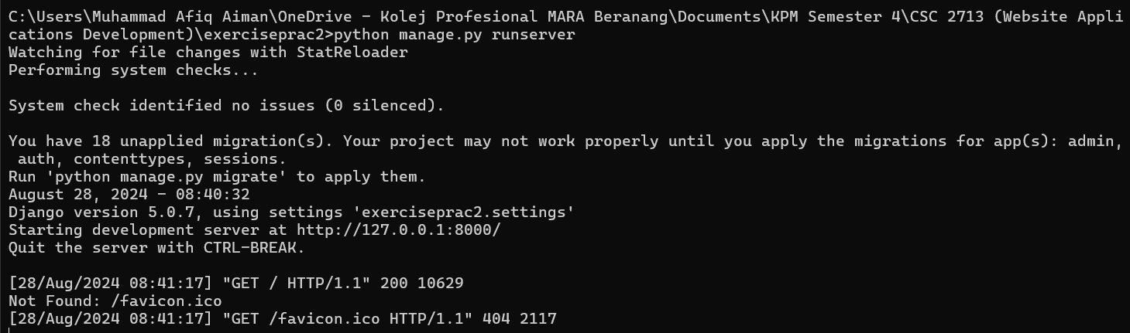Execute runserver command.
    3. Create a subproject name Grocer

**Part B: Create database. (Task 4-5)**

* + 1. 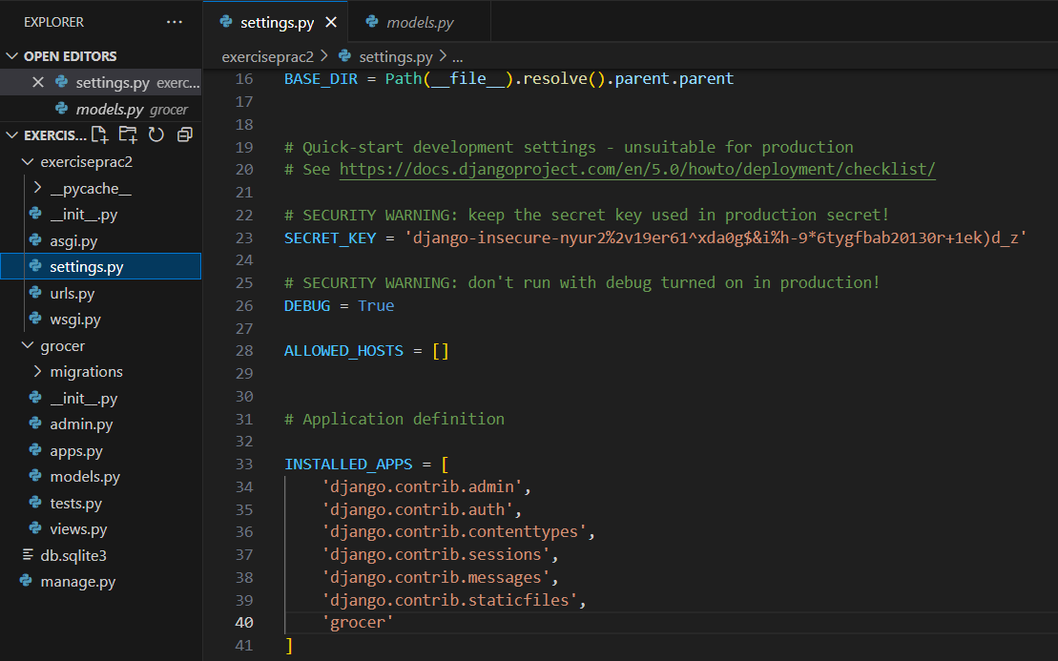Add application in installed apps setting.
    2. Create class based on the tables provided in overview above with appropriate:

1. Class name
2. Properties (data type, maximum number of character)
3. 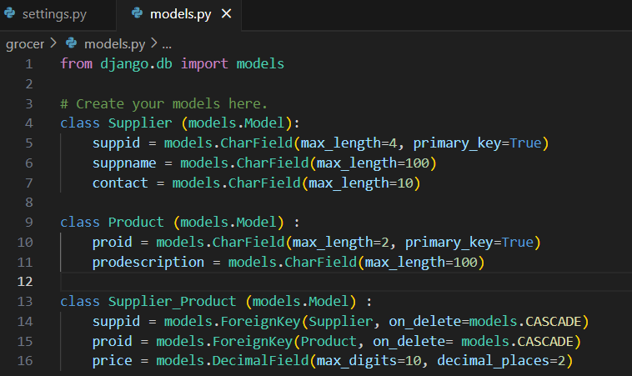Composition/aggregation

**Part C: Create / Update / Read / Delete objects (Task 6-13)**

* + 1. 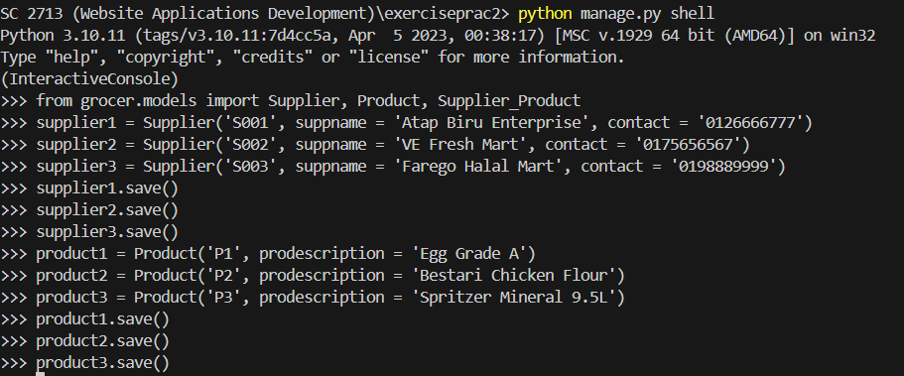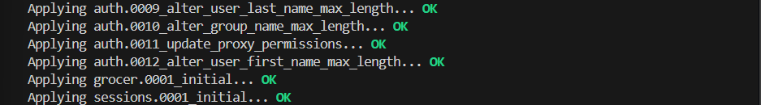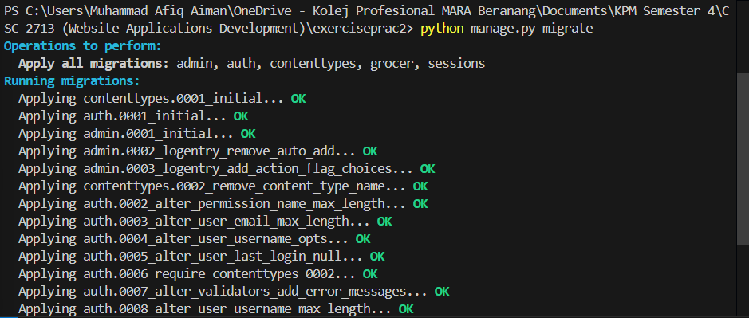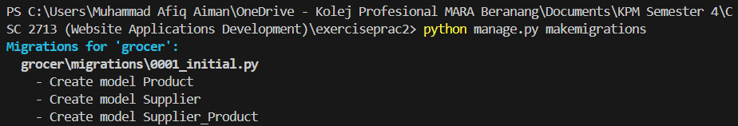Insert and save data into database.

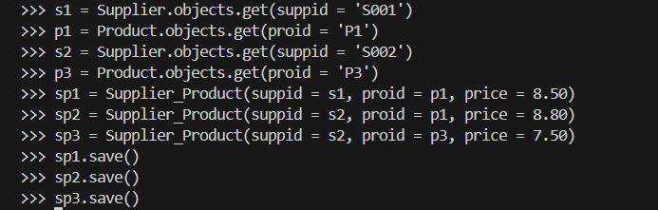

* + 1. Display data for all tables using command prompt.
    2. 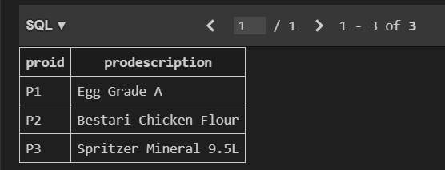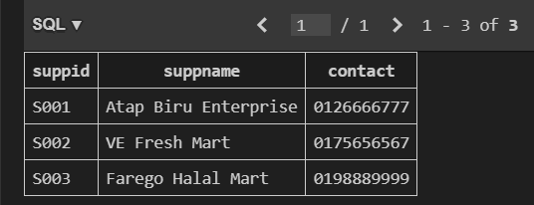Display all tables and its objects data using Visual Studio Code.

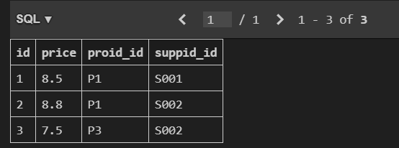

* + 1. Terminate interactive console by using command prompt and provide screenshot.
    2. 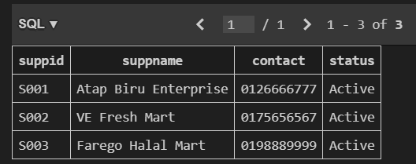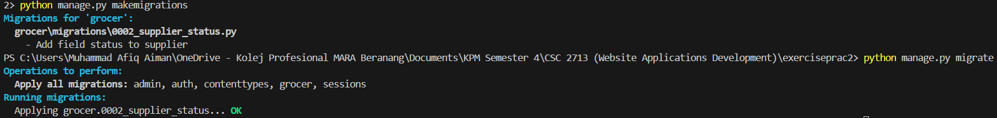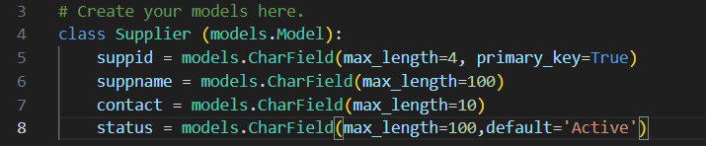Add new field Status in table Supplier and set default to ‘active’.
    3. 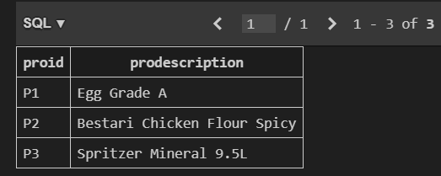Update **prodescription=Bestari Chicken Flour Spicy** in table Client for **proid=P2.**
    4. 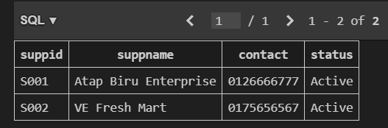Delete object in table **Supplier** for **suppid =S003.**



* + 1. Display data in all tables and its objects after executing all tasks until task 12.





### Assessment Rubrics:

| **No.** | **Task** | **Marks** | | **Mark Obtained** |
| --- | --- | --- | --- | --- |
| **Part A** | | | | |
| 1 | Create a django project name ‘yourstudentid’ for example: BCS2107001. | * Provide screenshot of correct command prompt to create a project. | 1 |  |
| * Correct projectname created. | 1 |  |
| 2 | Execute runserver command. | * Provide screenshot of success runserver command | 1 |  |
| 3 | Create a subproject name Grocer | * Successfully create subproject Grocer. | 1 |  |
| * Provide screenshot of correct command prompt. | 0.5 |  |
| * Provide screenshot for explorer and its files in project using Visual Studio Code. | 1 |  |
| Total (Part A) : | | | |  |
| **Part B** | | | | |
| 4 | Add application in installed apps setting. | * Correctly add application in installed apps setting. | 1 |  |
| * Provide screenshot installed apps setting. | 0.5 |  |
| 5 | Create class based on te tables provided in overview above with appropriate:   1. Class name | * Appropriate class name created. (Each class: 1m, Total: 3m) | 3 |  |
| 1. Properties (data type, maximum number of character) | * Appropriate data type and maximum length for appropriate field. (One field: 1m, Max: 3m) | 3 |  |
| 1. Composition/aggregation | * Correctly define key field. (Each class: 1m, Total:5m) | 5 |  |
| Total (Part B) : | | | |  |
| **Part C** | | | | |
| 6 | Insert and save data into database. | * Migration is success. (Each table: 2m, Total: 6m) | 6 |  |
| * Provide screenshot of successful migration in command prompt | 1 |  |
| * Provide screenshot showing fields for all tables in Visual Studio Code Sqlite Explorer. | 1 |  |
| * Able to open interactive console. | 1 |  |
| * Successfully create data in table with at least 1 object. (Each table: 1m, Total: 3m) | 3 |  |
| * Provide screenshot showing commands of opening interactive console and creating data. | 1 |  |
| 7 | Display data for all tables using command prompt. | * Provide screenshot for all tables containing at least one object using command prompt. (Each table: 0.5, Total:1.5m) | 1.5 |  |
| 8 | Display all tables and its objects data using Visual Studio Code. | * Provide screenshot for all tables containing at least one object using Visual Studio Code (Each table: 0.5, Total:1.5m) | 1.5 |  |
| 9 | Terminate interactive console by using command prompt and provide screenshot. | * Provide screenshot of a successfull terminating interactive console by using command prompt. | 1 |  |
| 10 | Add new field Status in table Supplier and set default to ‘active’. | * Provide screenshot of codings in file models. | 1 |  |
| * Provide screenshot showing updated field and objects in table using Visual Studio Code. | 1 |  |
| 11 | Update Update **prodescription=Bestari Chicken Flour Spicy** in table Client for **proid=P2.** | * Provide screenshot of a successful command prompt to update object. | 1 |  |
| 12 | Delete object in table **Supplier** for **suppid=S003.** | * Provide screenshot of a successful command prompt to delete object. | 1 |  |
| 13 | Display data in all tables and its objects after executing all tasks until task 12. | * Provide correct screesnshot for all tables and its objects after executing all tasks until task 12. | 1 |  |
| Total (Part C) : | | | |  |
| **Total Marks Earned** | | | | / 40 |
| **Total Percentage (20%)** | | | | / 20 |